Jeffrey Selby

Included documents:

IT Qualifications

Microsoft Certification

City Guilds Certificate

Degrees & Language Certificate

Degrees, University of NSW

German Oberstufe Certificate, Goethe-Institute

References

Harcourt 2005

Siemens 2003

Bankers Trust 1998

Note:
To ensure this file was a manageable size, only the most significant documents have been included.
Further documents (including all originals) can be presented upon request.

Microsoft Certification

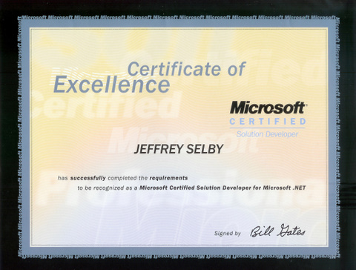

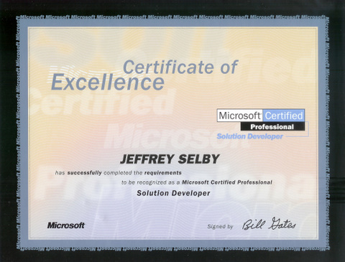

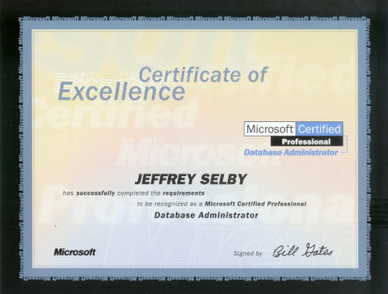

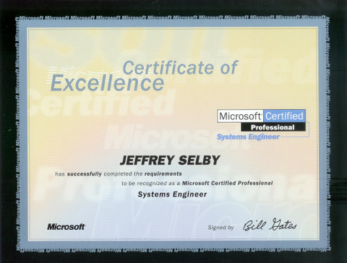

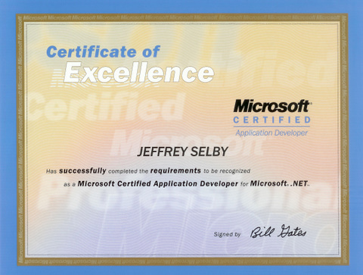

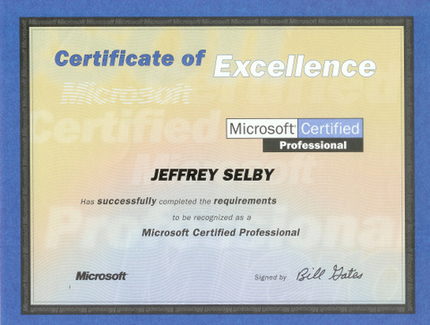

City Guilds Certificate for Information Technology

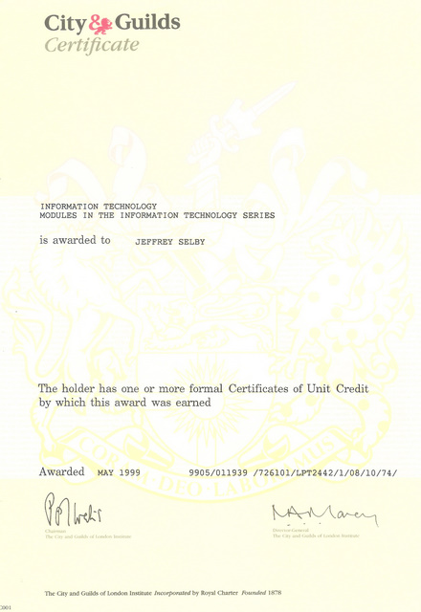

Goethe Institute: German Oberstufe Certificate

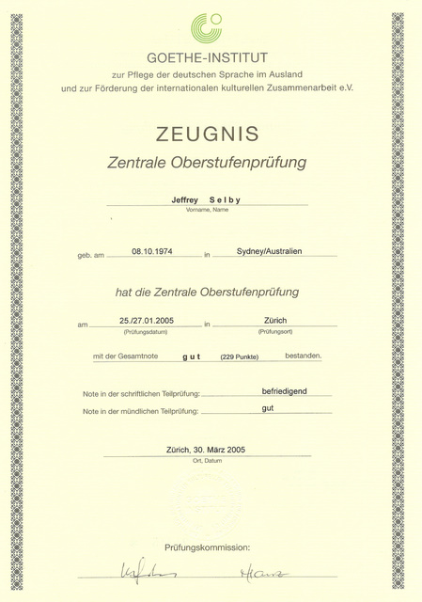

University Degrees

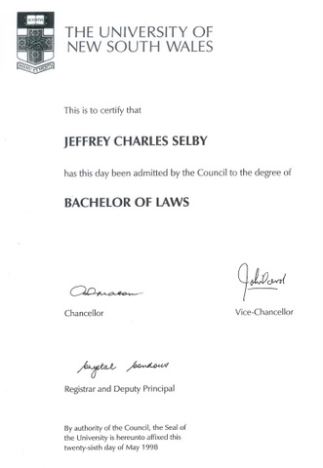

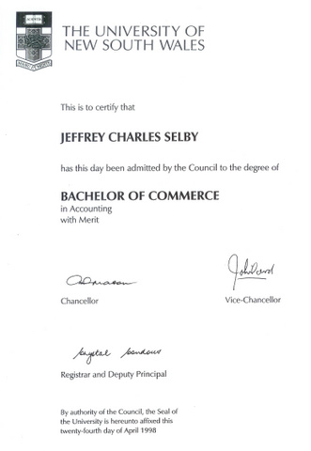

References

